Lab 2 Advanced Networks
Part II
There are 4 network interfaces:
Name | MAC Address | MTU | Duplex | Speed
lo | 00:00:00:00:00:00 | 65536 | N/A | N/A
enp131s0 | 00:e0:4c:68:f7:53 | 1500 | Unknown | Unknown
enp132s0 | 00:e0:4c:68:f7:51 | 1500 | Unknown | Unknown
enp128s31f6 | f4:f1:9e:38:2c:90 | 1500 | Full | 1000Mb/s

Disclaimer: lo is a loopback that allows the computer to commincate with itself
MTU determines how big the data inside the packet can be to travel across the internet. It is measured in bytes, so the 1500 would be 1500 bytes
To determine whether an NI is half or full duplex we need to use “sudo ethtool <NI name>”, then look for duplex. Some have unknown, which means that the physical cable is disconnected or the link is down

Part III: Addressing and DHCP

Ipv4 192.168.50.61
Subnet Mask: 24
CIDR Notation: 255.255.255.0 (indicated by /24)
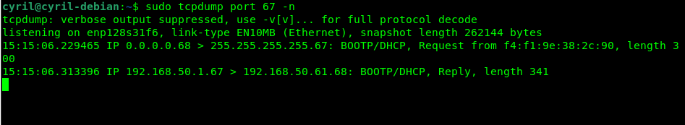
DHCP Server: 192.168.50.61.68
MAC: f4:f1:9e:38:2c:90

netdiscover
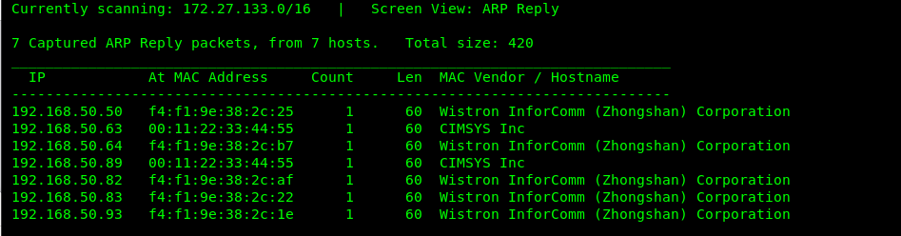
a: Arp reply
r: Arp request
u: unique hosts

An ARP table is a table or cache that relates an ip address to the MAC address of a device in a local network

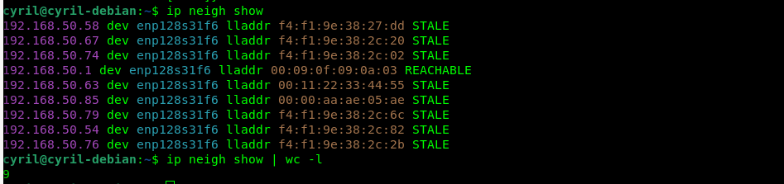
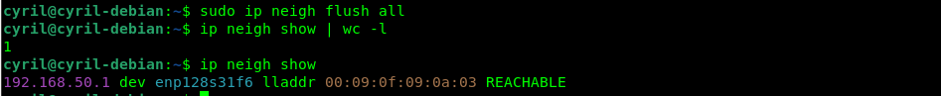
the system immediately recreates the ARP entry for your default gateway the moment a background process or network check sends a packet

